Unity Test Tools Released
December 18, 2013 in Company News and Info, Technology by Thomas Petersen
Through the past 2 years Unity QA has expanded and built tools, frameworks, and test rigs for internal use, something we have previously blogged about. Through all this work we have done, we have created a lot of value internally in Unity and we want to give our users access to these awesome tools. Today we have released version one of the Unity Test Tools on the Asset Store. Get it here:
Thus we made the decision to make Unity Test Tools available for our users, which we hope will help you attain a high quality in your code while developing your games.
Unit Test
The lowest and most efficient level to do automation is at the unit level. We have decided to use nUnit as the basis for our unit test framework, which is a well known framework for those already writing unit tests.
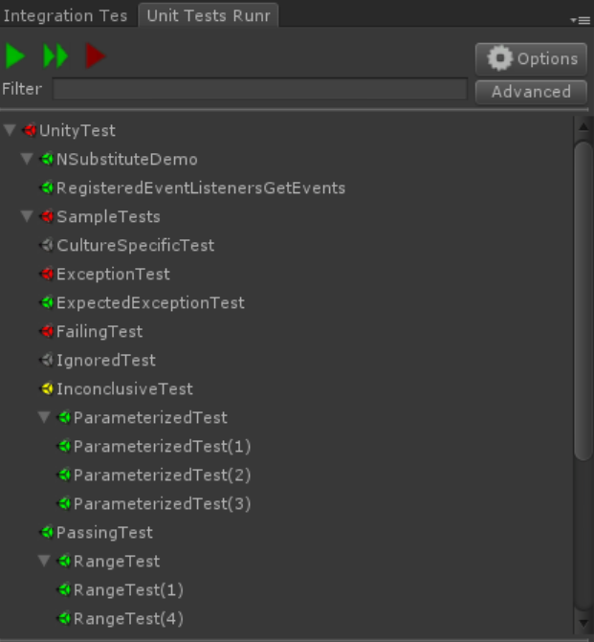
We have ensured that the integration to the editor is intuitive and simple, with the option of having automatic execution on every recompile, so you have immediate feedback while you write your code. Another important aspect of a test framework is the ability to make a build pipeline where unit tests are executed without a head and the Unity Test Tools give you this option as well.
Integration Test
In order for you to test the integration between components, objects and assets, you need a higher level of tests and for this we have made the Integration Test Framework. Integration tests are also the easiest way of starting to write automation tests on a game in development, since they don’t have requirements on the architecture of the code.
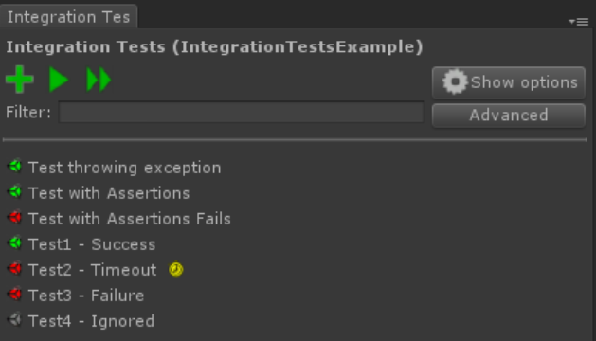
The simplest use of these would be to make a scene, use assets and gameobjects, and set up the conditions you want to verify. The execution is as simple as with the unit tests, where the execution will cycle through the scenes containing tests and execute each test for you. This framework can also be integrated into a build pipeline seamlessly, so you can test all levels of your project from commandline.
Assertion Component
The assertion component is able to monitor the state of gameobjects while in playmode and pause the game if the condition is met. The primary use is debugging, where you can make the game stop in the exact frame the condition is met, thus enabling you to see the entire picture of when it occurs.
To help manage the assertion components, we have added an explorer which is similar to a list of breakpoints in code, so you have an overview of the states and where the components are placed. The component can evaluate complex conditions runtime and thus is more powerful than a normal breakpoint.
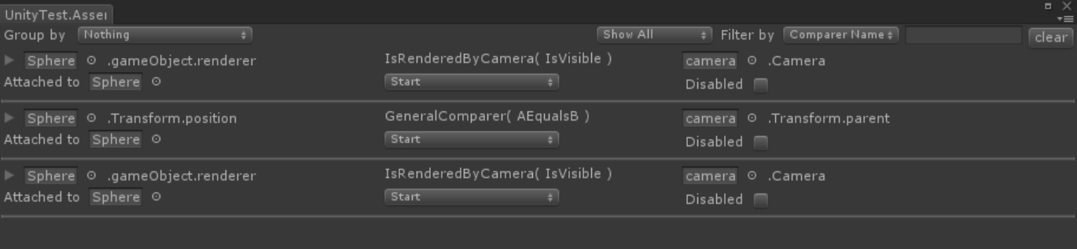
In order to enable the build and release pipeline, we have made it possible for you to disable assertion components in release builds, thus making sure you don’t hit them in a released game.
Examples
In the package you download you will find a full set of examples and a comprehensive documentation on how each of the tools work.
The Future
Releasing the tools is just the beginning for us. We will be committed to release tutorials and patterns which will help you structure your projects such that they are testable. We will also continue improving on the tools and increase integration into Unity, all with the aim of making it easy for you to start testing your projects.
Happy testing!

